Online Chapter Work Instructions for Developing Literacy Skills

Students will Logon and go to “ www.wilswood.weebly.com “

Students will go to the “Current Classes” tab section

Students will complete the Standardize Test Practice Section for Chapters 4,5,6&7
Samples of the section to complete are Pasted in below.

Go to
ch04_carpentry_se.pdf
Download File

You will find only 3 Multiple Choice Questions for each Chapter or 3 Short Response Questions. They are located at the end of the Chapter, sample of Ch. 4 below.
Please read the questions first and then read through from the beginning to find the correct Choice or input for your short response answers.
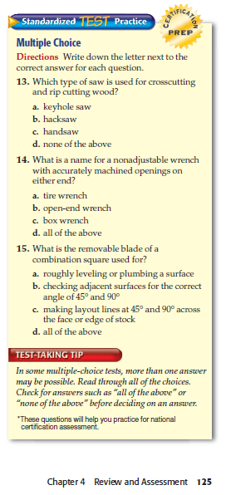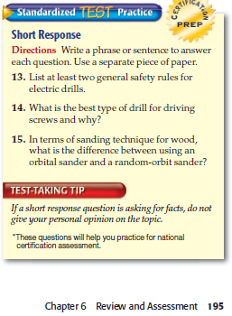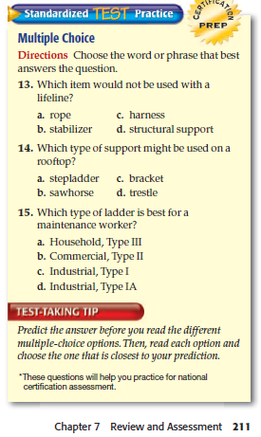
Please complete your Work in Word Perfect, print and submit to Teacher.

